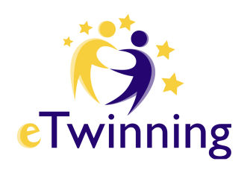
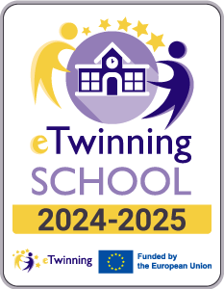


PARENTAL CONSENT

School Name
(Recipient of consent)
School Complex
Student’s Surname and First Name
Class/Section
Parent’s Surname and First Name
Parent’s Surname and First Name

Dear Parent/Guardian,
the section/class of your son/daughter will participate in the realization of the educational project …………………………………………………………………………………………..

This authorization is necessary to collect the consents required within the framework of the European program “eTwinning".

I, the undersigned ………………………………………………………., in the capacity of …………………… of the student ……………………………………………….., authorize the aforementioned institution to film, record the voice, photograph the minor, and use his/her educational productions or artistic creations related to this project.

Date: …./…./…
Parent or Guardian Signature: …………………………………..

I, the undersigned ………………………………………………………., in the capacity of …………………… of the student ……………………………………………….., authorize the aforementioned institution to film, record the voice, photograph the minor, and use his/her educational productions or artistic creations related to this project.

Date: …./…./…
Parent or Guardian Signature: …………………………………..

PLEASE NOTE: This authorization form must be completed and signed by both parents or by the legal guardian of the student participating in the indicated project. Every activity planned by the “eTwinning” projects has an educational purpose. The student without consent participates in the activities, but his/her images will not be published and his/her face will not be visible.

